Already planned on medical insurances or waiting for some hard-core disease to knock your gateway? It’s high time to act! Watch out on the meals you take. Is it healthy enough to accompany you comfortably to old age or provide you a lifestyle you want to have after retirement? If you have any doubts, then you have landed on the right place!
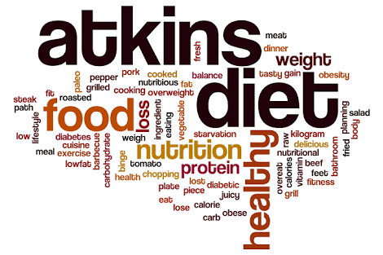
Presenting, ATKINS DIET, one-stop solution to your puzzled mind.

Engaged in working for a company so much that you forgot to prioritize your own body? Have a look on the benefits and risks of Atkins diet and follow Atkins diet benefits for improved results.
What is Atkins diet good for? Is Atkins diet unhealthy?
For weight loss? For gaining back the active body? It has stored much more for you! But, what is Atkins diet good for? What are the disadvantages of Atkins diet? What are the drawbacks of Atkins diet? What might be the problems with Atkins diet?
Atkins diet benefits you in eliminating common heart diseases, diabetes, metabolic syndrome, epilepsy, headache/ early migraines and leave your body with an updated version.
It contains a low-carb diet plan that inculcates a control over the body, releases unnecessary stress and gains rigidity against luscious but harmful diet products.
A serious problem that arises: benefits and risks of Atkins diet move hand in hand!
What is Atkins diet good for is far inferior to why Atkins diet is bad.
- It claims to reduce serious illness by providing a mechanism which your body might or might not adopt!
- The process of Atkins diet includes 4 stages:
First, total elimination of carbs from routine (abstracts the info why Atkins diet is bad). Second, begin to take a minimal amount (or just taste) carbs. Third being gradual increase in its quantity in Atkins diet and fourth stage requires taking an amount your body can lightly digest.
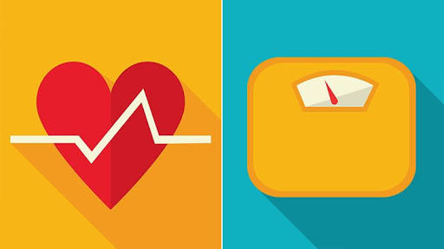
It can be related to a hammer thumping on a steel box. Initially, the energy is transferred to the box and no visible changes are found. Then after some time though, it changes shape and turned into as required. The same way Atkins diet benefits in cutting off fats and the weighing machine scale ticking backwards.

But are these obvious drawbacks of Atkins diet here? Let’s see an example. How will a fish react if it is deprived of water and can see a tank full just beside it. It will jump into the tank for survival instincts! Similarly, if our body is suddenly deprived of our routine, it will crave for more.
Atkins diet side effects
It promotes a risk of loss of energy, welcomes lethargy followed by weakness, dizziness and an unfocussed mind searching for food everywhere. Disadvantages of Atkins diet can also count dullness as a factor, which can destroy inner peace to an extent. Cramps and heart palpitations might occur leading problems with Atkins diet mentioned earlier.
Sometimes, a directed routine is hard to follow when your body runs in opposite directions. You have to be careful with visible outcomes and continue the diet accordingly.
Is Atkins diet unhealthy?
Every thing has its bright and dark side and so do benefits and negatives of Atkins diet has. Problems with Atkins diet is, you can experience a sudden weight loss in a week or two. But that's just a temporary pleasure. It pressurises to follow up a strict diet even after end of 4 stages.
We had HUNDREDS OF LECTURES on having a balanced diet to stay fit which treated carbohydrates equally important, then why the need to boycott carbs?
Reason that pretty sums up: Our body requires a limited amount of fats. And carbs act as just a substitute which turns into a bad habit. That is what Atkins diet is good for.
Atkin diet side effects treatment
- ‌Drink surplus fluids with salts.
- ‌Increase intake of fibres and fats (for a few days so as to fulfill the deficiency).
- ‌If you struggle from heart palpitations, take long breaths and stay calm. That's common.

